Wendy Kramer
PO Box 1571 Nederland, CO 80466 wendy@donorsiblingregistry.com (303) 258-0902 www.DonorSiblingRegistry.com
Education
Bachelor of Arts, Magna Cum Laude, 1980
Long Island University
Professional Experience

Business Management – 1980-2009

Business management, financial management and accounting for small and medium sized organizations. Restaurant owner, 7 years.

Co-Founder and Director, Donor Sibling Registry (DSR) 2000-Present
The DSR is a charity organization, founded in 2000 by Wendy Kramer and her donor conceived son Ryan, to assist individuals conceived as a result of sperm, egg or embryo donation that are seeking to make mutually desired contact with others with whom they share genetic ties. With more than 70,000 worldwide members, the DSR has helped to facilitate contact between more than 18,500 people with their half siblings and/or their donors (biological parents).
Without any outside support, the DSR has pioneered an international discussion about the donor conception industry and the families, with its research, speaking engagements and media appearances. Wendy has authored and co-authored many published articles and papers on donor conception, has reviewed abstracts for the American Society of Reproductive Medicine (ASRM), and has also been a peer reviewer for the journals Human Reproduction, Social Science and Medicine, and RBM Online. Wendy and her son Ryan have appeared on 60 Minutes, The Oprah Winfrey Show, Good Morning America, CBS Sunday Morning, and many other news shows and publications such as the NY Times, TIME and Newsweek.
Television and Book
2011: Associate Producer on the Emmy nominated TV show Sperm Donor.
2013: Associate Producer of MTV News & Docs series, Generation Cryo, 6 episodes.
2013: Co-Author of “Finding our Families: A first-of-a-kind-book for Donor-Conceived People and their Families”, published by Penguin Random House 2013.
2018: Author of the children's book Your Family: A Donor Kid's Story,

2020: Author of the book: Donor Family Matters: My Story of Raising a Profoundly Gifted Donor-Conceived Child, Redefining Family, and Building the Donor Sibling Registry.

Published Research
The following research has been presented at meetings and conferences around the world, including: ASRM, ESHRE, British Fertility Society, Australian Fertility Society, CRYO, Human Reproduction, ASPIRE and several sociology, family, mental health, genetics, bio-ethics, academic, gynecology and obstetrics, legal and LGBT conferences in North America, Europe, Australia and Asia.

2019: Personal Relationships (Journal of the International Association for Relationship Research): Attachment in donor-conceived adults: Curiosity, Search and Contact
Elizabeth Lozano, R Chris Fraley and Wendy Kramer.

2017: Reproductive Bio Medicine Online: Long-term breast cancer risk following ovarian stimulation in young egg donors: a call for follow-up, research and informed consent. Jennifer Schneider, MD, Jennifer Lahl, and Wendy Kramer.
2016: Fertility and Sterility: Integrating donor conception into identity development: Adolescents in fatherless families. Collaboration with Cambridge University, UK and The New School, NY
2016 Journal of Family Issues: Donor Sibling Networks as a Vehicle for Expanding Kinship: A Replication and Extension. Rosanna Hertz, Margaret K. Nelson and Wendy Kramer DOI: 10.1177/0192513X16631018
2016 Children And Society: Adolescents conceived through donor insemination in mother-headed families: A qualitative study of motivations and experiences of contacting and meeting same-donor offspring. Collaboration with Cambridge University, UK and The New School, NY
2015 EC Gynaecology: (Commentary) The Need For Comprehensive Genetic Testing of Gamete Donors

2015: Reproductive Biomedicine and Society: Emerging models for facilitating contact between people genetically related through donor conception: a preliminary analysis and discussion. M. Crawshaw, K. Daniels, K. Bourne, D. Adams, J.A.P Van Hoof, L. Pasch, P. Thorn http://dx.doi.org/10.1016/j.rbms.2015.10.001

2015 Social Science and Medicine: Gendering gametes: The unequal contributions of sperm and egg donors. Margaret Nelson, Rosanna Hertz and Wendy Kramer doi:10.1016/j.socscimed.2015.10.049
2015 The Journal of Law and the Biosciences: Gamete Donor Anonymity and Limits on Numbers of Offspring: The Views of Three Stakeholders. . Margaret Nelson, Rosanna Hertz and Wendy Kramer. http://jlb.oxfordjournals.org/content/early/2015/10/28/jlb.lsv045.full.pdf?keytype=ref&ijkey=R1RUEPvvSoHwIFf
2015 Facts, Views & Vision in OB/GYN (the Scientific Journal of the Flemish Society of Obstetrics, Gynaecology & Reproductive Health): Sperm Donors Describe the Experience of Contact with their Donor-Conceived Offspring. Margaret Nelson, Rosanna Hertz and Wendy Kramer
2013 Chapter published in book “Visions of the 21st Century Family: Transforming Structures and Identities”: Making Sense of Donors and Donor Siblings: A Comparison of the Perceptions of Donor-Conceived Offspring in Lesbian-Parent and Heterosexual-Parent Families. Margaret Nelson, Rosanna Hertz and Wendy Kramer
2013 Reproductive BioMedicine Onine: A Survey of 1700 Recipients of Donor Sperm: the views of women who formed their families using donor spermatozoa. Neroli Sawyer, Eric Blyth, Wendy Kramer and Lucy Frith.
2013 Advances in Reproductive Sciences: Genetic and Health Issues Emerging from Sperm Donation: The Experiences and Views of Donors. Ken Daniels and Wendy Kramer.
2013 The Journal of Family Issues, A New Path to Grandparenthood: Parents of Egg and Sperm Donors. Authors: Diane Beeson, Patricia Jennings, Wendy Kramer
2013 Social Science and Medicine: Donor-Conceived Offspring Conceive of the Donor: The Relevance of Age, Awareness, and Family Form. Rosanna Hertz (Wellesley College), Margaret K. Nelson (Middlebury College), Wendy Kramer
2012 Reproductive BioMedicine Online: Semen donors who are open to contact with their offspring: issues and implications for them and their families. Authors: Ken Daniels, Wendy Kramer and Maria Perez-y-Perez.
2012 Reproductive BioMedicine Online: Perspectives, experiences and choices of parents of children conceived following oocyte donation. Authors: Eric Blyth, Wendy Kramer, and Jennifer Schneider.
2012 Asia Pacific Journal of Reproduction: Donor type and parental disclosure following oocyte donation. Authors: John Stephenson, Eric Blyth, Wendy Kramer, and Jennifer Schneider
2012 Reproductive BioMedicine Online: Forming a family with sperm donation: a survey of 244 non-biological parents. Authors: Lucy Frith, Neroli Sawyer, and Wendy Kramer.
2011 Human Reproduction: Offspring searching for their sperm donors: how family type shapes the process. Authors: Diane Beeson, Wendy Kramer, and Patricia K. Jennings.
2010 Human Reproduction: Sperm and oocyte donors’ experiences of anonymous donation and subsequent contact with their donor offspring.* Authors: Tabitha Freeman, Vasanti Jadva, Wendy Kramer, Susan Golombok.
2010 Reproductive BioMedicine Online: Experiences of offspring searching for and contacting their donor siblings and donor.* Authors: Vasanti Jadva, Tabitha Freeman, Wendy Kramer, Susan Golombok. This paper was nominated for the 2011 Robert G. Edwards Prize Paper Award.
2009 Human Reproduction: The experiences of adolescents and adults conceived by sperm donation: comparisons by age of disclosure and family type.* Authors: Vasanti Jadva, Tabitha Freeman, Wendy Kramer, Susan Golombok.
2009 Human Reproduction: Gamete donation: parents’ experiences of searching for their child’s donor siblings and donor.* Authors: Tabitha Freeman, Vasanti Jadva, Wendy Kramer, Susan Golombok.
2009 Human Reproduction: US oocyte donors: a retrospective study of medical and psychosocial issues. Authors: Wendy Kramer; Jennifer Schneider and Natalie Schultz
*Partnership with the Family Centre, University of Cambridge, UK

Speaking Engagements

2020
January 2020: Colorado Center for Reproductive Medicine, Denver, CO: “Disclosures and Discussions” panel. A workshop run every year for families who have used a 3rd party for reproduction.

2019
November 2019: 6th International Conference on Gynecology and Obstetrics, Paris, France: Theme: Focus on Next Generation and to Improve Obstetrics and Gynecology Care
November 2019: 27th World Congress on Controversies in Obstetrics, Gynecology & Infertility (COGI), Paris, France: Research on 2,013 Donor Offspring
July 2019: The European Society of Human Reproduction and Embryology (ESHRE), Vienna: Poster Presentation on Donor Offspring Research
June 2019: RESOLVE Walk of Hope, Englewood, CO: Booth
June 2019: Midwest Reproductive Symposium International (MRSi), Chicago, IL: Invited speaker: DNA=Donors Not Anonymous
May 2019: Asia Pacific Initiative on Reproduction (ASPIRE), Hong Kong: 2 talks: One on donor-conceived people and one on DNA testing/anonymity (DNA=Donors Not Anonymous)
January 2019: Colorado University School of Law: Bioethics & the Law Class
January 2019: British Fertility Society, Birmingham, UK

2018
November 2018: Conference of The Foundation for Reproductive Medicine, NYC
October 2018: Icahn School of Medicine at Mount Sinai, NYC
October 2018: Philadelphia Family Pride Family Matters Conference
October 2018: ASRM Meeting: Poster by our partners from the University of Illinois at Urbana-Champaign: Attachment in Donor Conception: Curiosity, Search, and Contact
September 2018: Conceptions Reproductive Associates of Colorado
August 2018: Boulder Bookstore: Book signing for Your Family: A Donor Kid's Story
June 2018: RESOLVE Walk of Hope, Englewood, CO
March 2018: 26th European Congress of the European Board & College of Obstetrics and Gynecology, Paris, France
February 2018: University of San Diego School of Law, Center for Health Law Policy & Bioethics
January 2018: British Fertility Society, Liverpool, UK: Talk: "Infertility and Donor Conception: Pregnancy is Just the Beginning!"

2017
October 2017: American Bar Association, Beaver Creek, CO
September 2017: Colorado Center for Reproductive Medicine, Lone Tree, CO
June 2017: RESOLVE Walk of Hope, Englewood, CO
May 2017: The Aristotle University of Thessaloniki, Laboratory for the Research of Medical Law and Bioethics, the Bar Association of Thessaloniki, and the Medical Association of Thessaloniki International Conference, Thessaloniki, Greece: Talk: “Medicine, Law and the Internet”
February 2017: The European Meeting Days of the French Society of Gynecology, Paris, France: Poster

2016
December 2016: NY Genome Center, NYC: "Are you your genome?" A panel discussion about the human side of genetics: exploring the connections between identity, heritage, and genetic information.
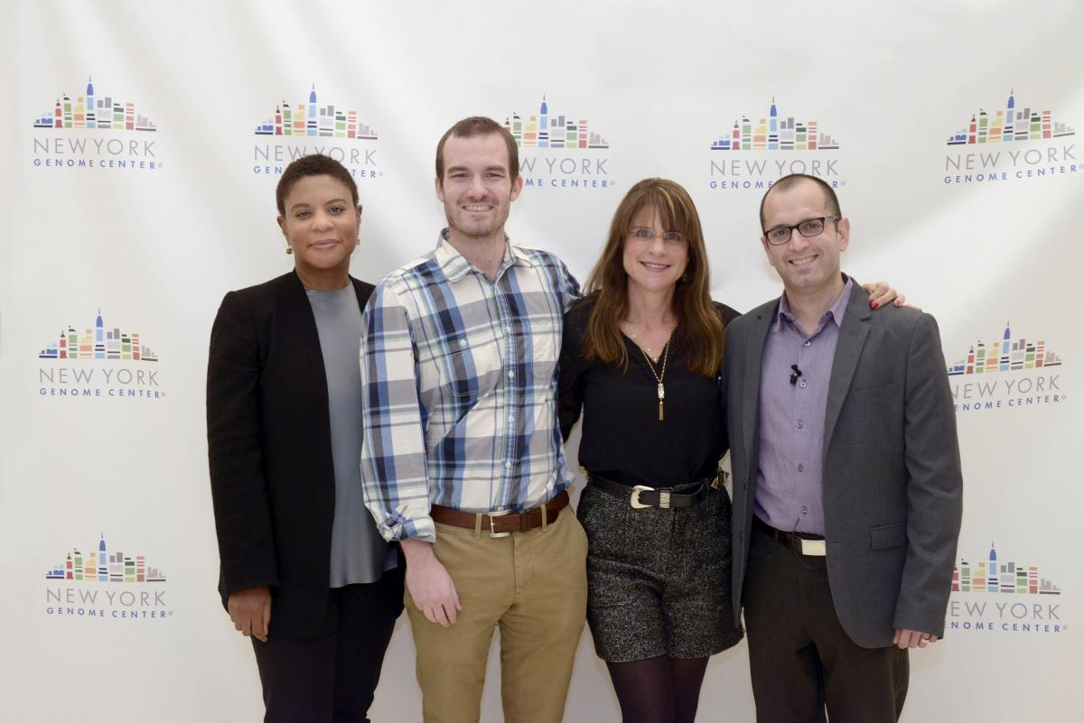
November 2016: 20th anniversary of CONCEBIR/Bi-annual meeting of the American Network (Red TRAscender), Buenos Aires, Argentina: Video Part 1, Video Part 2, Video Part 3

September 2016: HQA Fertility Fair, Colorado Springs, CO
May 2016: BIT’s 4th International Congress of Gynaecology and Obstetrics (ICGO-2016), Barcelona, Spain: Oral presentation: "The Donor Sibling Registry (DSR) — A Global Registry for Donor Families"
April 2016: 37th Annual American Adoption Congress International Conference in Denver, CO: "Trailblazing Change: Moving Mountains Together in Adoption"
March 2016: 17th World Congress of Gynecological Endocrinology, Florence, Italy: Poster: For the Infertile Couple: 5 Things You Need to Know and Oral presentation: The Case for Comprehensive Genetic Testing of Gamete Donors

2015
November 2015: Reproductive Rights, New Reproductive Technologies, and the European Fertility Market, Santander, Spain: The DSR presented two talks
October 2015: 11th World Congress of the European Society of Gynecology (ESG), Prague, Czech Republic: Two oral presentations: "Infertility and creating donor-conceived children: Pregnancy is just the beginning, not the end of the journey" and "Connecting with offspring: sperm donor attitudes"
October 2015: ASRM Meeting, Baltimore, MD: Two presentations: "Adolescents Conceived Through Donor Insemination: An In-Depth Qualitative Study of the Experiences of Contacting and Meeting Donor Siblings" and "Integrating Donor Conception into Identity: Parent-Child Relationships and Identity Development in Donor Conceived Adolescents." Jenna Slutsky, MA Center for Attachment Research, The New School for Social Research; Dr. Vasanti Jadva, Centre for Family Research, University of Cambridge; Dr. Tabitha Freeman; Sherina Persaud, MA; Wendy Kramer, The Donor Sibling Registry; Dr. Miriam Steele; Dr. Howard Steele; and Professor Susan Golombok.
September 2015: Skype interview with master's students in Bioethics and Science Policy at Duke University
September 2015: 22nd World Congress on Controversies in Obstetrics, Gynecology & Infertility (COGI), Budapest, Hungary: Oral presentation: "Infertility and Donor Conception: Pregnancy is just the beginning!"
April 2015: Stanford University Law School: Talk sponsored by Law Students for Reproductive Justice
March 2015: 16th World Congress on Human Reproduction, Berlin, Germany: Two papers: "Sperm donors who are open to contact with their offspring" (poster) and "The Donor Sibling Registry — a global registry for donor families" (oral presentation)

2014
November 2014: Merck's Conference: The 2nd Red TRAscender Congress, Mexico City, Mexico: With the Latin American Parents Infertility Organization
October 2014: The First European Workshop of the Italian Association of Gynecological Endocrinology and the 7th Albert Netter Days of the European Society of Gynecology, Capri, Italy: Abstract: "After Pregnancy: What are the needs, rights, and issues of Donor-Conceived People?" (PDF)
June 2014: Skype workshop with a GLBTQ parents group in Boston after they watched the Family Equality Council webinar
May 2014: Webinar: "The Donor Sibling Registry: Helping People Discover Their Roots" for the Embryo Adoption Awareness Center
March 2014: 2014 Annual Meeting of the Pacific Coast Reproductive Society, Palm Springs, CA
March 2014: Family Equality Council Webinar: The Donor Sibling Registry: Educating, connecting and supporting donor families
January 2014: Boulder Bookstore, Boulder, CO: Book signing for Finding our Families: A First-of-Its-Kind Book for Donor-Conceived People and Their Families

2013
August 2013: American Sociological Association Annual Meeting: Paper presentation: "Donor Conceived Offspring Conceive of the Donor and Donor Siblings in Lesbian-Parent and Heterosexual-Parent Families." Presented by co-authors R. Hertz and M. Nelson.
July 2013: Television Critics Association (TCA) Press Tour, Los Angeles, CA: Our upcoming MTV News & Docs docu-drama series, Generation Cryo, was one of the fall shows premiered at this event.
June 2013: 2-day workshop, Montreal, Canada: “Donor Conception: Lessons for Clinicians, Families, Policy Makers, and Researchers” (Wendy's handout)
June 2013: 1-day workshop, University of Minnesota, MN: “Revamping the Law & Policy of Reproductive Technologies: Children First?”

2012
September 2012: Asia Pacific Initiative on Reproduction (ASPIRE ) Conference, Osaka, Japan: Lunchtime talk by Ryan and Wendy: The Donor Sibling Registry (DSR) — A Global Registry for Donor Families
July 2012: European Society of Human Reproduction and Embryology (ESHRE) Conference, Istanbul, Turkey: 1700 Sperm Donor Recipients
April 2012: American Adoption Congress, Denver, CO
March 2012: Pacific Sociological Association Conference in San Diego, CA: "Sperm Donor-Conceived Children Speak out about Donor Conception." Patricia K. Jennings (CSU East Bay) and Wendy Kramer (Donor Sibling Registry). Presented by Pat Jennings.
March 2012: CU Law School, Boulder, CO: Sponsored by the Law Students for Reproductive Justice and the Health Law Society

2011
December 2011: 14th World Conference on Human Reproduction, Melbourne, Australia: Plenary Speaker, Merck Serono Symposia and Donor Linking Symposium
October 2011: Single Mothers by Choice 30th Aniversary Gala, NYC
April 2011 and August 2012: Embryo Adoption Awareness Center: Webinars
April 2011: 2nd International Congress on Controversies in Cryopreservation of Stem Cells (CRYO Conference), Valencia, Spain: Reproductive Cells, Tissue & Organs: Two abstracts presented: The Case for Comprehensive Medical and Genetic Testing of Gamete Donors, presented in the session "Ethics and Social Consequences of Electively Deferring Motherhood through Oocyte Cryopreservation" and Semen donors who are open to contact with their offspring (poster)
January 2011: Fertility 2011, Dublin, Ireland: British Fertility Society, et al. Two abstracts: "Anonymity, disclosure, and contact with donors: How experiences of donor-conceived offspring vary by family type" and "Semen donors who are open to contact with their offspring"

2010
November 2010: National Council on Family Relations, Minneapolis, MN
October 2010: ASRM Conference, Denver, CO: Two abstracts: "Anonymity, disclosure, and contact with donors: How experiences of donor-conceived offspring vary by family type" and "Semen donors who are open to contact with their offspring"
July 2010: Genetics and Society Meeting, Tarrytown, NY
April 2010: Asia Pacific Initiative on Reproduction (ASPIRE) Conference, Bangkok, Thailand: Two presentations: "A Survey of 164 Sperm Donor"s and "The Case for Comprehensive Medical and Genetic Testing of Gamete Donors"
March 2010: University of Denver, Denver, CO: Sturm College of Law, Motherhood Conference
February 2010: L.A. Gay and Lesbian Center, Los Angeles, CA
January 2010: Fertility 2010, British Fertility Society, Bristol, UK: The Case for Comprehensive Medical and Genetic Testing of Gamete Donors

2009
June 2009: European Society of Human Reproduction and Embryology (ESHRE) Conference, Amsterdam, The Netherlands: US oocyte donors: a retrospective study of medical and psychosocial issues
January 2009: Fertility 2009, British Fertility Society, Edinburgh, Scotland: US oocyte donors: a retrospective study of medical and psychosocial issues

2008
October 2008: Infertility Network, Toronto, Canada: Ethics and Gamete Donation
March 2008: DePaul University College of Law, Chicago, IL: Symposium: Tracking Change

2007
March 2007: Association of Health Care Journalists, Los Angeles, CA

2006
July 2006: Association of Managers of Gynecology & Obstetrics, Denver, CO

2005
October 2005: Infertility Network Symposium on Donor Conception, Toronto, Canada

DSR/Cambridge University Collaboration Presentations
October 2008: Fertility Society of Australia (FSA) Meeting, Brisbane, Australia
June 2008: ESHRE Meeting, Barcelona, Spain
October 2007: American Society of Reproductive Medicine (ASRM) Meeting, Washington, DC

